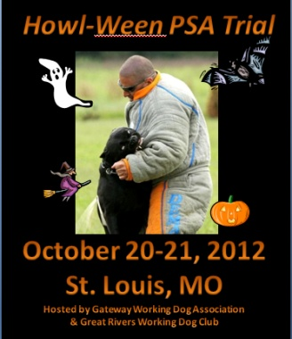 | October 20-21, 2012  PSA Club Trial  Hosted by Gateway Working Dog Association &  Great Rivers Working Dog Club  9550 Highway NN Cedar Hill, MO 63016 | 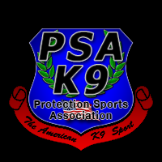

All entries paid the day of the trial MUST BE PAID IN CASH. NO EXCEPTIONS. Pre-entries/payment must be received by midnight October 11th to receive $10 discount on entry and $5 discount on t-shirt (see design above left). Please send the completed registration form via e-mail at marenbelljones@gmail.com and send check (to Maren Bell Jones):
Maren Bell Jones (Attn: PSA Trial Registration), 5405 Arrow Wood Dr, Columbia, MO 65202
All levels are $65. Indicate level & day for which you are entering:

 | ^{Saturday} | ^{Sunday}
^{PDC Sleeve}
^{PDC Suit}
^{PSA 1}
^{PSA 2}
^{PSA 3}

Handler Name: | PSA Membership #
Street Address: | Phone Number:
E-mail Address: | City, State, Zip Code:
Emergency Contact: | Emergency Phone Number:
Dog's Registered Name: | Dog's Call Name:
Breed: | Working Titles:
Handler Owner Trained? Y/N | Dog's Age:
Long Sleeve T-shirt Size (add $25 for pre-register, $30 after 10-11-12, $2 extra for XXL): | TOTAL Amount Enclosed (entry + t-shirt):

RELEASE: It is the understanding that the above handler / dog team are entering this trial AT THEIR OWN RISK. I understand that serious accidents can and do occur during dog training, competitions and other dog related events / activities. I am assuming all risk, liabilities and responsibilities and will hold harmless PSA K9, Gateway Working Dog Association, The Tom Rose School, Great Rivers Working Dog Club, their agents, partners, employees, sponsors from ANY AND ALL liability arising from this dog-related event and practice training while at Sweetcorn Kennel. I also agree to hold harmless any of the above mentioned from any property damage, theft, death or personal injury to my dog or myself. I also agree to have complete control over myself and my dog(s) at all times. By signing this entry form I acknowledge that I have read and understood the trial waiver and read and understand all PSA rules that govern trials. There will be no refunds given to any handler that has been ejected from this trial for any reason. In addition, by signing this release I give consent to any representative of PSA and Gateway Working Dog Association/Great Rivers Working Dog Club to take pictures of events and any activities surrounding the events, said pictures shall be the sole and exclusive property of PSA for their sole and exclusive use and distribution. Further by signing this, I release any rights to the sale, posting or distribution of any pictures taken by representatives of PSA and waive any right to renumeration or compensation for any picture taken or sold of the events in question.

SIGNATURE: Date:

